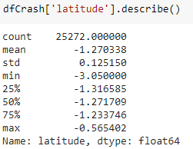

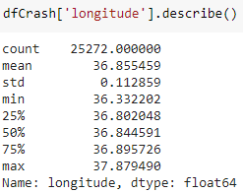

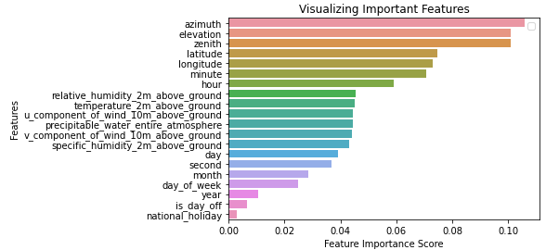

Time zone -3, Random forest

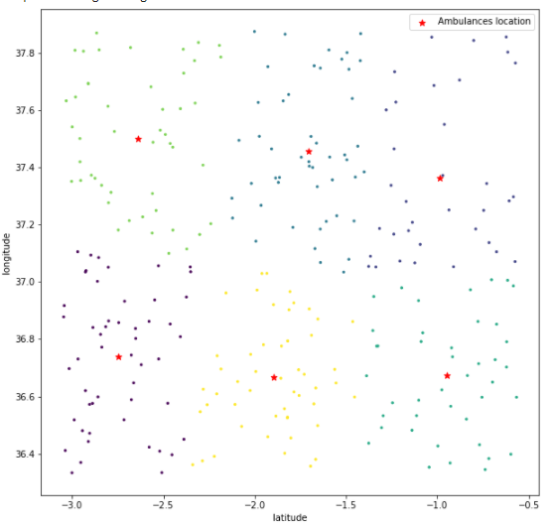

|  |
| --- |
| Ambulance Location For – Time zone 3 |
| [-2.74473827, 36.73875905] |
| [-0.98552441, 37.36197124] |
| [-1.70586475, 37.45590102] |
| [-0.94985487, 36.67220806] |
| [-2.63965247, 37.50083687] |
| [-1.89652329, 36.66578275] |

Time zone -2, Random forest

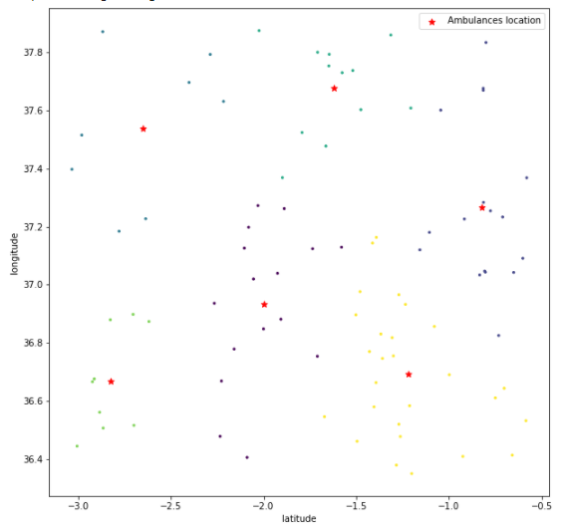

|  |
| --- |
| Ambulance Location For – Time zone 2 |
| [-1.99900765, 36.93278538] |
| [-0.82084953, 37.26684971] |
| [-2.65011818, 37.54000612] |
| [-1.6222563 , 37.67812828] |
| [-2.82647136, 36.66900329] |
| [-1.21971844, 36.6930236 ] |

Time zone -2, SVM forest

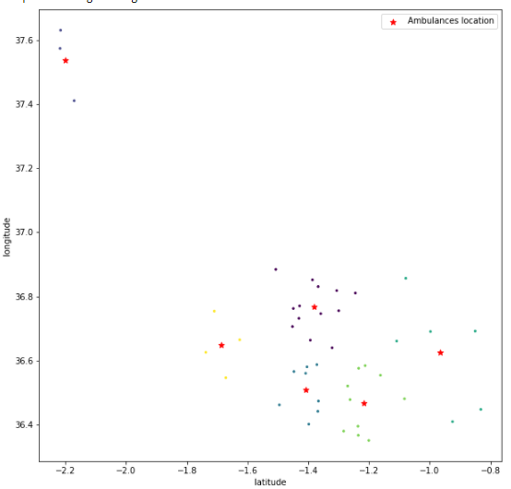

|  |
| --- |
| Ambulance Location For – Time zone 2 |
| [-1.38015108, 36.76673074] |
| [-2.201255 , 37.53928814] |
| [-1.40723179, 36.50829414] |
| [-0.96501831, 36.62561554] |
| [-1.21774543, 36.46775386] |
| [-1.68590506, 36.64723214] |

Timezone-3, SVM

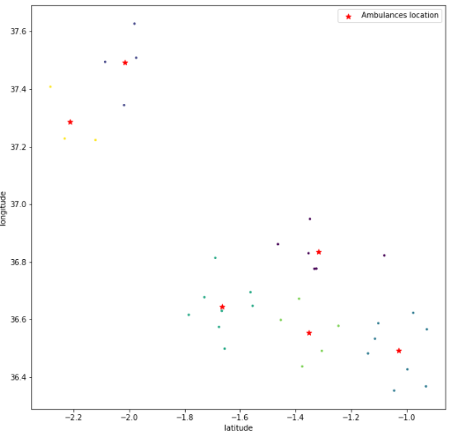

|  |
| --- |
| Ambulance Location For – Time zone 3 |
| [-1.31706048, 36.83578258] |
| [-2.01499278, 37.49369612] |
| [-1.02857965, 36.49216989] |
| [-1.66476216, 36.6438078 ] |
| [-1.35349569, 36.55504617] |
| [-2.21232559, 37.28651609] |